**Course Project   
DeVry University  
College of Engineering and Information Sciences**

**Course Number: CEIS236**

**Course Project Deliverable: 3**

**Part I: Tables Created:** Screenshot of tables below:

select * from customer;

select * from line;

select * from vendor;

**PART II:** Single table queries screenshots

Problem 1: Write the SQL code required to list only the first five records in the Customer table. **Please note that YOUR first name and YOUR last name should show up in the first record.** Take a screenshot of your results. (hint: use the LIMIT condition after the table name)

Problem 2: Write the SQL code required to list the product code, description, and price from the product table. Take a screenshot of your results.

Problem 3: Modify the query above to only show those products that cost more than 20. Take a screenshot of your results. 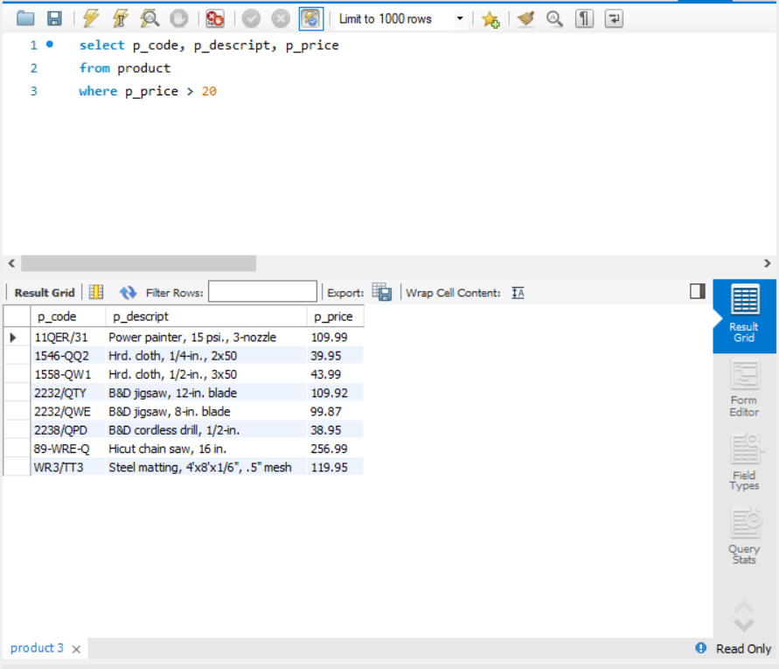

Problem 4: Modify the Problem 2 query above to show the results with price descending. Take a screenshot of your results.

Problem 5: Modify the Problem 3 query above to show products that cost more than 20 and less than 100. Take a screenshot of your results. 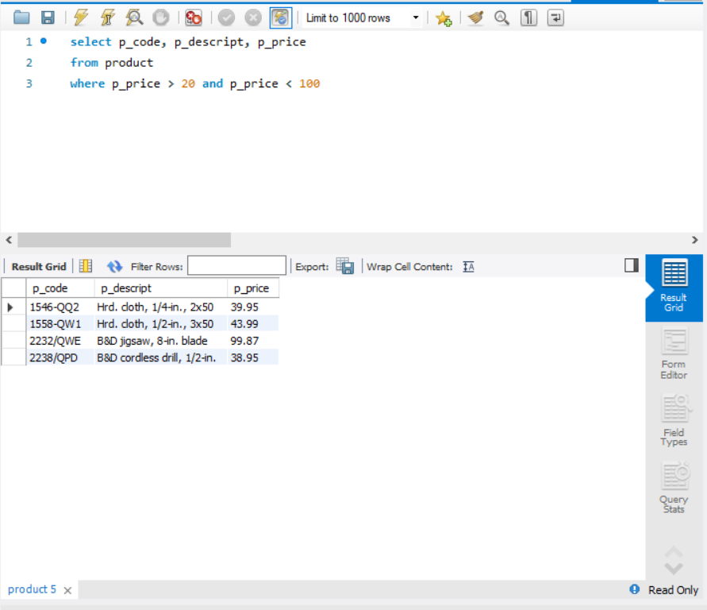

Problem 6: Write the SQL code required to list the first name and last name of all customers whose middle initial is G. Take a screenshot of your results (hint – you should get two names) A screenshot of a computer

Problem 7: Write the SQL code required to list the code, first name, last name, and balance of all customers whose last names begin with O. Take a screenshot of your results (hint: you should get 3 names) A screenshot of a computer
